We are seeking students in Grade 5 & 6 to take on the role of Standing Patrol.

Students Needed for Standing Patrol

The requirements for this position are listed below. The Learning Skills and Work Habits you will have the opportunity to build and demonstrate are shown in brackets followed by other words in italics that can be used to describe the same work habit.

For example, a coach or volunteer supervisor may have said you are “Reliable” and have good “Teamwork” skills. This is like saying you are “Responsible” and a good “Collaborator”. Knowing different words used to describe work habits can help you relate your school experiences to your experiences outside the classroom.

As a member of the Standing Patrol, you will also have an opportunity to build and demonstrate your Essential
Skills. These skills are used in work, learning and life. Essential Skills are shown in bold after the work habits.

• Read the rules and responsibilities thoroughly. (Responsibility, Reliability, Reading Text)

• Arrive promptly at your assigned post for your scheduled shift. (Responsibility, Organization, Independent Work,
Reliability, Scheduling or Budgeting and Accounting)

• Always wear your safety vest when on duty. (Responsibility, Reliability, Working Safely)

• Communicate and work collaboratively with your fellow Standing Patrol, Bus Driver, Staff Members, and students
to discuss plans and issues that come up. (Collaboration, Teamwork, Oral Communication)

• Assist students to cross the street safely, while ensuring your own safety. Always be sure to incorporate your Standing Patrol Safety Training and excellent customer service skills - be friendly and polite. (Responsibility, Initiative, Reliability, Customer Service, Working Safely)
• In a positive and supportive way, remind students to follow the school rules and to treat each other with respect.
(Responsibility, Initiative, Reliability, Customer Service, Oral Communication)

• Decide when to alert the Principal or Vice-Principal if you have any problems or concerns. (Initiative, Responsibility, Self-Regulation, Reliability, Working Safely, Self-advocacy, Decision Making)
• Be aware of what is going on around you. (Responsibility, Reliability, Working Safely)

• In the morning, return to the school when you hear the morning bell. Ensure that you still arrive to school on time. (Responsibility, Organization, Reliability)
• Be a positive role model for all students at all times. You are an ambassador of our school in the community. (Self-Regulation, Responsibility, Initiative, Customer Service, Reliability)
• Find a replacement Standing Patrol should you be unable to complete one of your shifts. (Responsibility,
Initiative, Reliability)

Standing Patrol - page 2
You can transfer your Essential Skills and work habits to everyday life or the next place you go – whether it’s
further education, training or the workplace. More information on how you use your Essential Skills and work habits in everyday life is on the Ontario Skills Passport website.
Identifying and reflecting on the Essential Skills and work habits you demonstrate as a member of the Standing Patrol will help you develop your “All About Me” portfolio as you answer the four education and career/life planning inquiry questions: Who am I? What are my opportunities? Who do I want to become? What is my plan for achieving my goals?

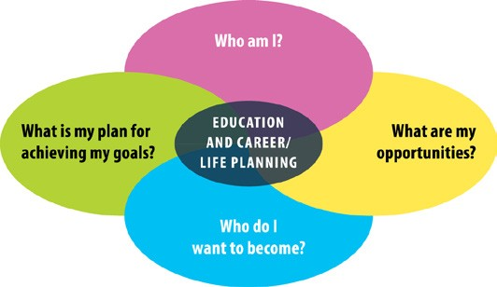

ontario.ca/skillspassport

